**Weekly Status Update for Week 8**

**Timeline:** From 24-04-2024 to 01-05-2024

**What we have done:**

**Code:**

* Log into the website using institution account, show institution admin page. Songxuan,Bohong,Nuoxi

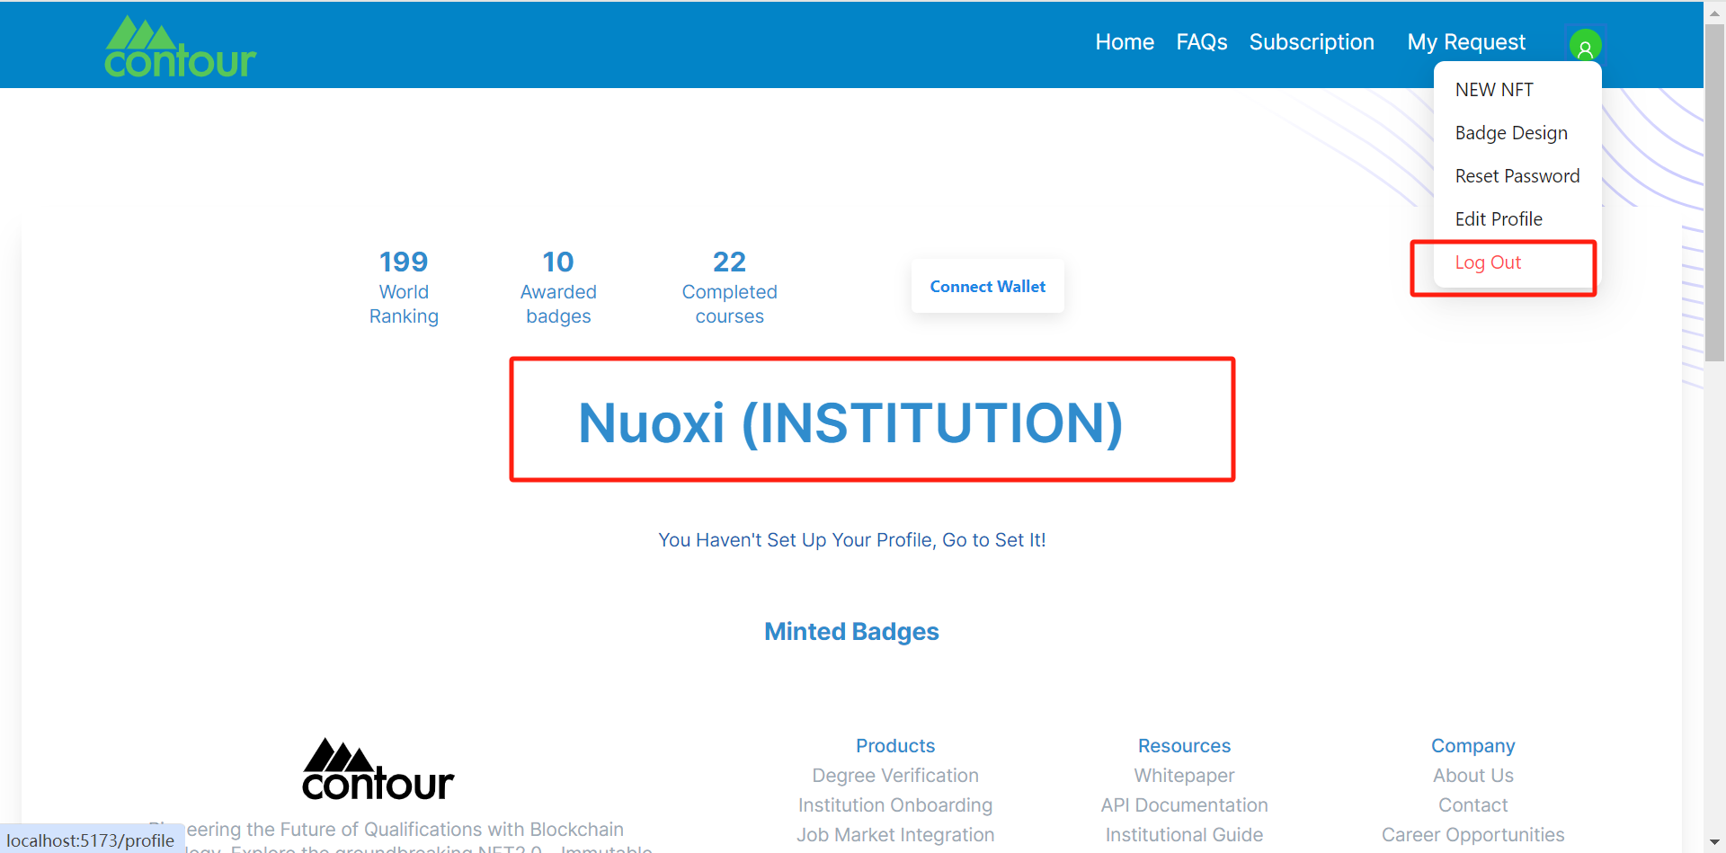

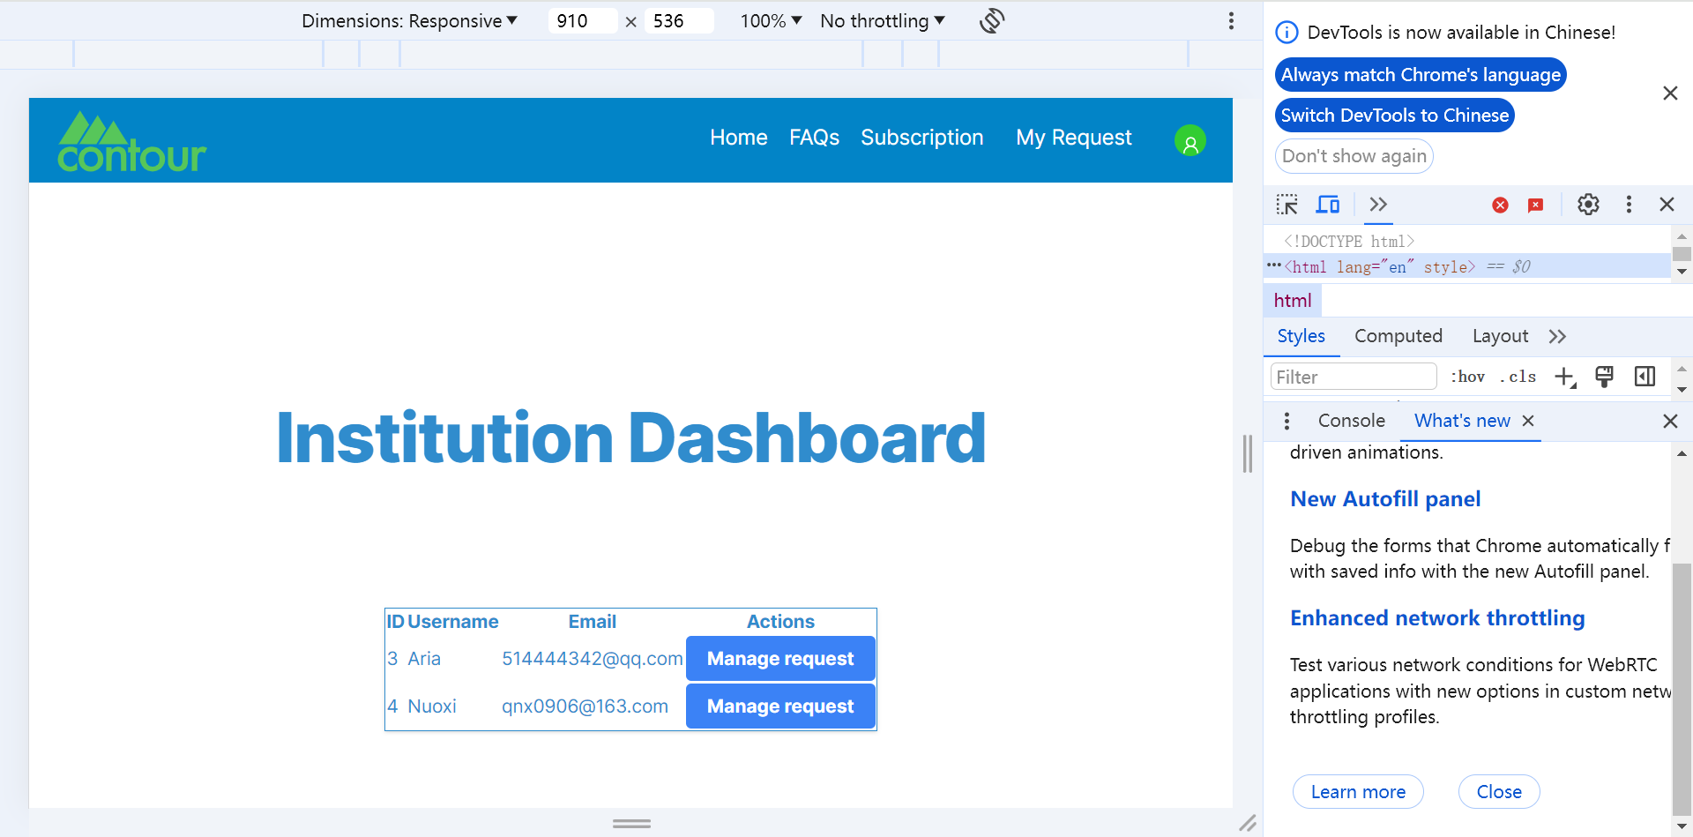

* [**Add ”institution admin board component“ in header**](https://github.com/perspicacious-slinki/Immutable2024s1ANUTechlauncher/issues/217) Nuoxi

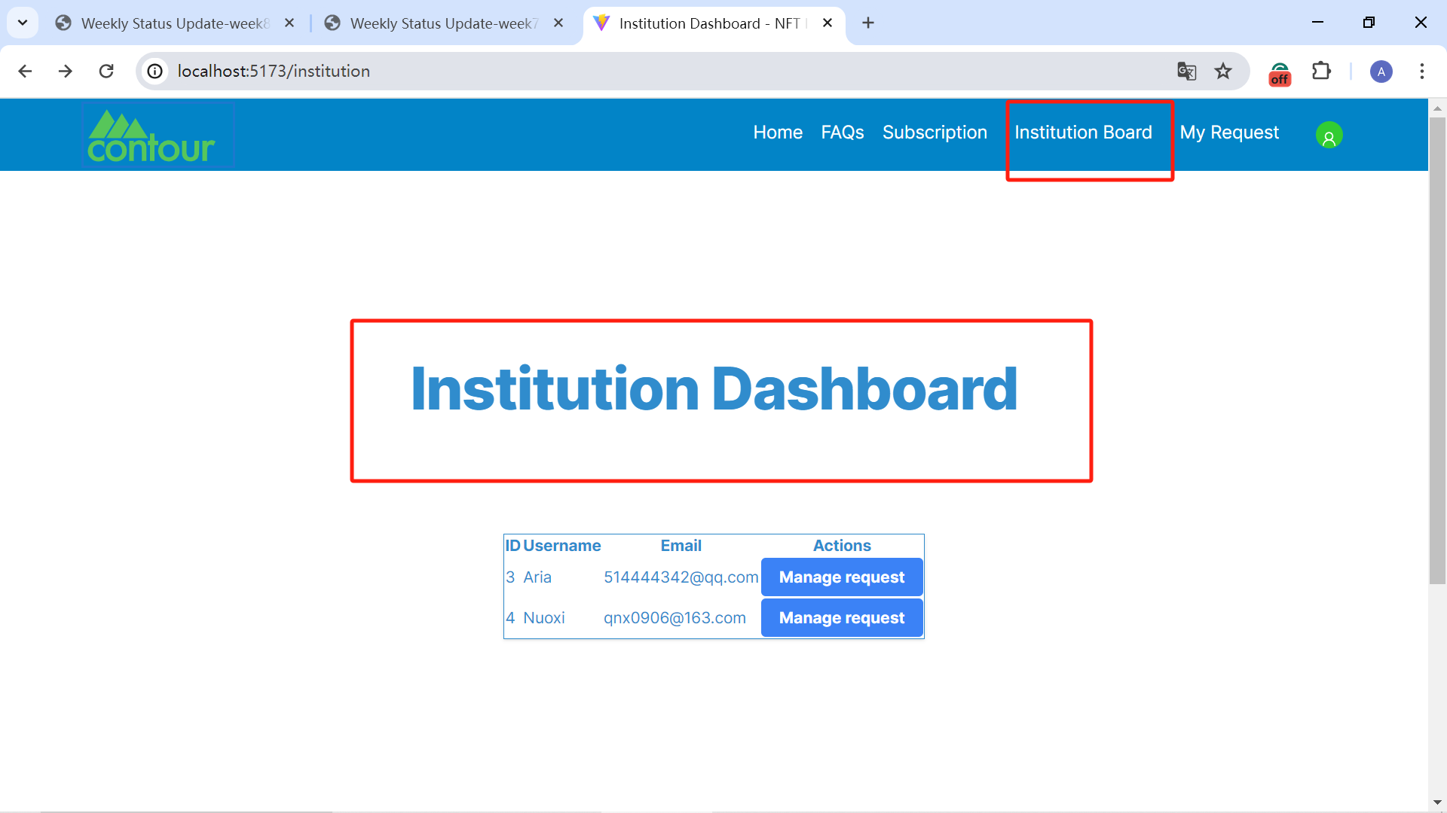

* Link Institution admin page to modal page (manage request) Andy

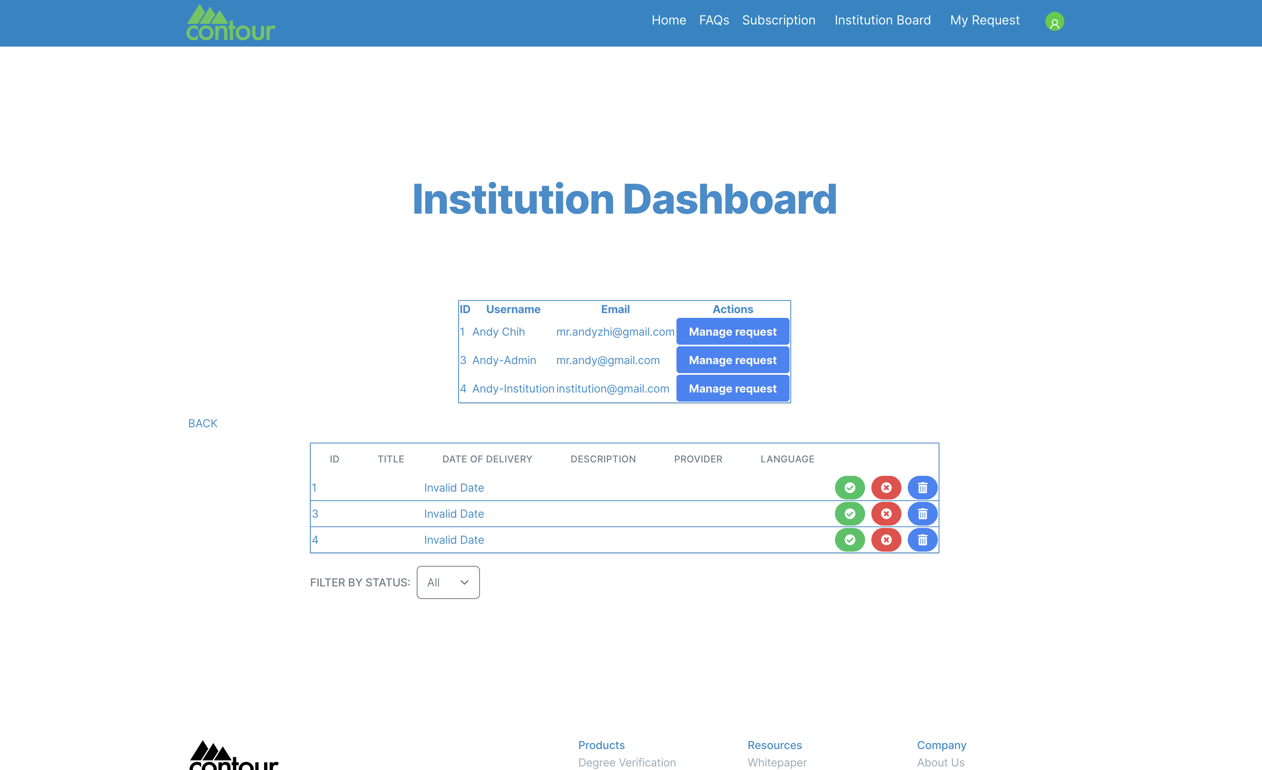

**Documentation**: Mitchell

**What we will do next week:**

* ALL members prepare for video and poster and ppt and script audit3

**Code:**

* Institution manage request function (add view edit request metadata button) Linxi
* Calling the classify requests by institution function written in the backend on the frontend Andy
* Fix some possible bugs Nuoxi,Songxuan, Bohong
* Start researching going live to the web server Nuoxi,Songxuan, Bohong

**Documentation**: Mitchell

* Mitchell will start web hosting report